EXPERIMENT 5

Aim
Simulation of Static Routing in Cisco Packet Tracer

Prerequisite
Nil

Outcome
To impart knowledge of Computer Networking Technology

Theory
Static routing is a method of configuring network routers to use a fixed, predetermined path or route for forwarding data packets from the source to the destination. In contrast to dynamic routing, where routes are determined dynamically based on network conditions and routing protocols, static routing requires network administrators to manually configure and maintain the routing tables. Here's an explanation of static routing:
- Manual Configuration:
In a static routing setup, network administrators manually define the routing tables on each router in the network. These routing tables contain information about which network addresses or subnets are reachable and through which next-hop router or interface data packets should be forwarded.

- Predictable and Simple:
Static routing is straightforward and easy to configure. It is often used in small to medium-sized networks where the network topology is simple and stable. Because routes are manually defined, the network behavior is predictable and does not change dynamically.

- Use Cases:
  - Static routing is commonly used for simple network setups, such as small office networks or home networks.
  - It can be used for routing between isolated networks or network segments where the topology rarely changes.
  - In scenarios where security is a concern, static routing can be employed to ensure that traffic follows a specific path, reducing the risk of unauthorized routing changes.

- Limitations:
  - Static routing does not adapt to network changes. If a router or link fails or if the network topology changes, manual updates to the routing tables are required to maintain connectivity.
  - In larger and more complex networks, static routing can become difficult to manage and may lead to routing inefficiencies.
  - It's not suitable for load balancing or optimizing traffic in dynamic network environments.

- Examples:
  - A small office with a single router connecting to the Internet might use static routing to direct all outgoing traffic to the ISP's gateway.
  - In a lab or test network, static routes can be configured to simulate specific network conditions for testing and troubleshooting.
In summary, static routing is a basic method of configuring routers to define fixed routes for data packets. It is ideal for small, stable networks where simplicity and predictability are more important than adaptability to changing network conditions. In larger, dynamic networks, dynamic routing protocols like OSPF and BGP are typically preferred for their ability to adapt to changes in the network.

Procedure:
- Open Cisco Packet Tracer and simulate the sample topologies for Static Routing.
- Perform Necessary Operation on Router to create and configure Static Routing.
- Check the connectivity between the devices.

Steps:
- Topology Setup: Create your network topology in Cisco Packet Tracer with routers and connections.
- IP Address Configuration: Assign IP addresses to router interfaces and connected devices.
- Basic Connectivity: Ensure basic connectivity between devices.
- Static Route Configuration: Set up static routes on routers to specify how to reach different subnets.
- Testing Static Routes: Verify that the static routes work as expected by testing connectivity.
- Save Configurations: Save router configurations to persist changes.

Output:
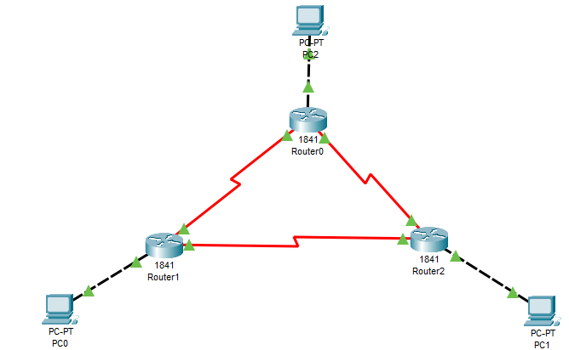
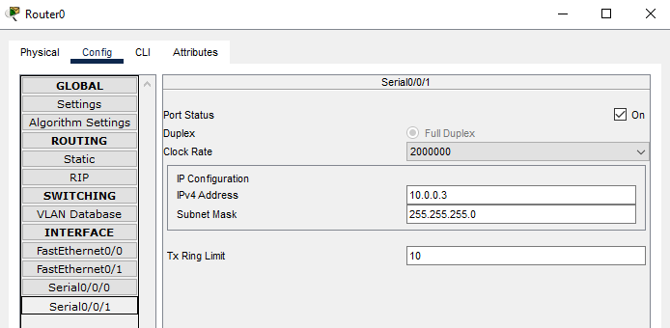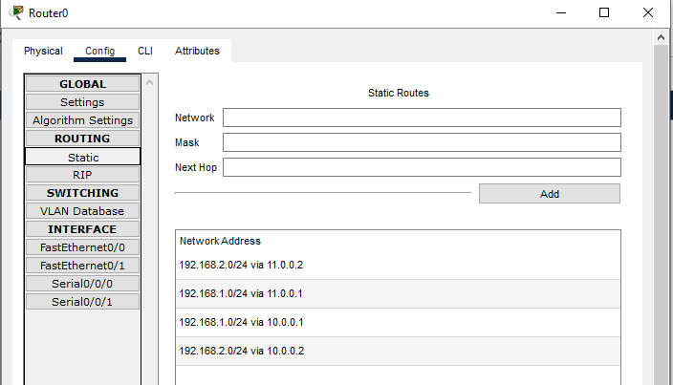
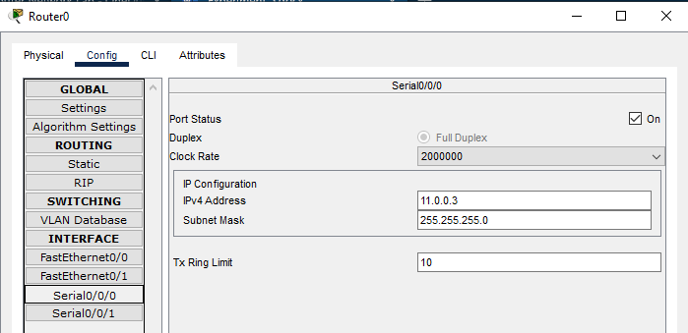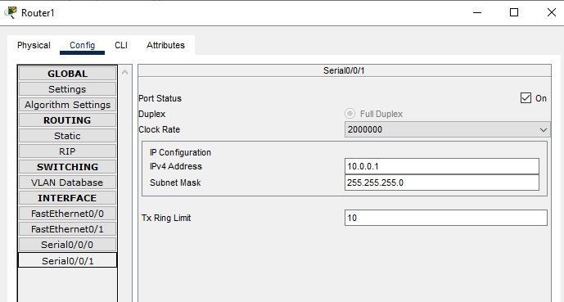
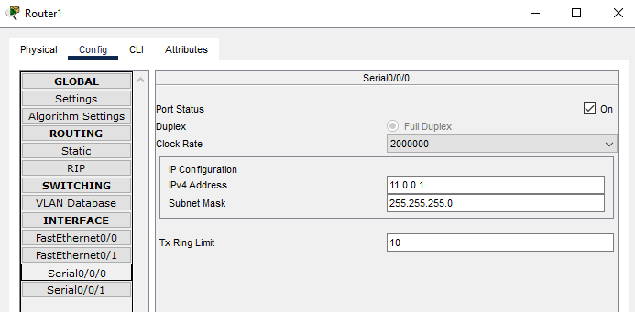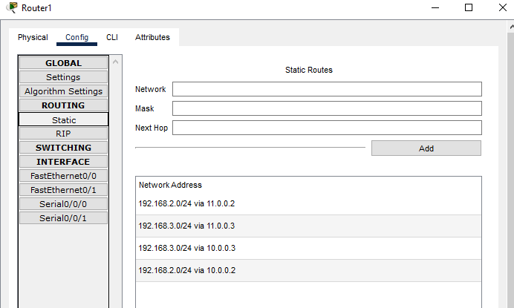
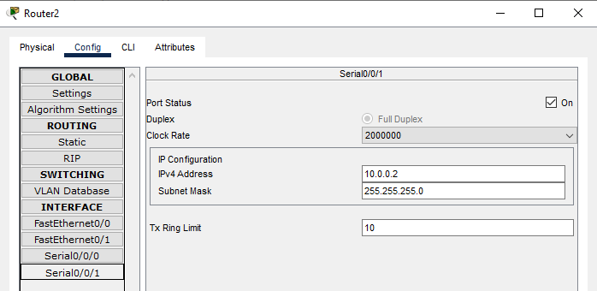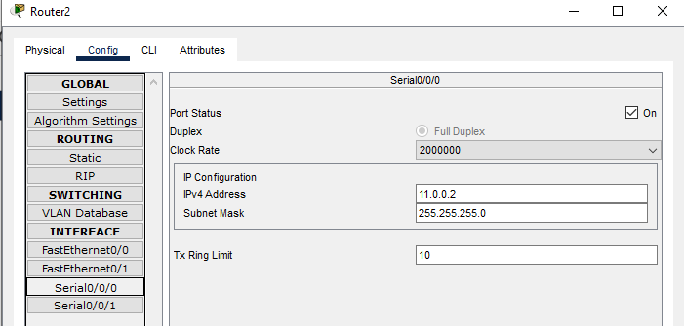
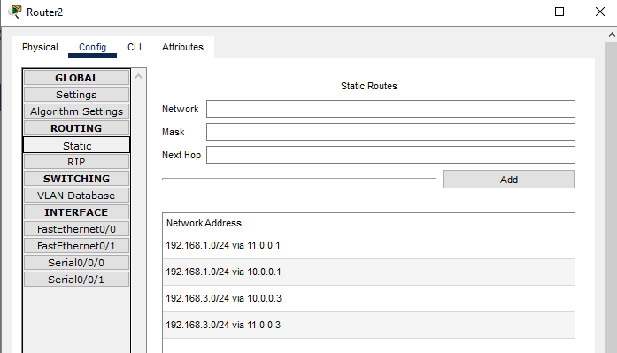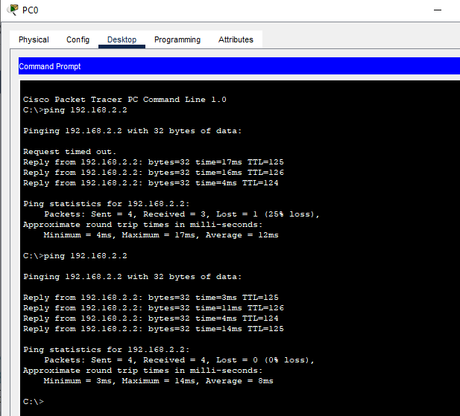

Observation & Learning
In the experiment with Cisco Packet Tracer, I observed the successful setup of a network topology, IP assignment, and basic connectivity. Static routing was configured to enable inter-subnet communication, and testing validated its functionality. I learned the importance of network setup, the suitability of static routing for simple networks, the necessity of connectivity verification, and the limitations of static routing in dynamic or large networks.

Conclusion
In summary, the experiment showed the successful use of static routing for inter-subnet communication. It emphasized the importance of precise network setup and connectivity verification. However, for dynamic or larger networks, dynamic routing protocols are a more suitable choice due to their adaptability.

